**WEB APPLICATIONS AND AI: A COMPREHENSIVE OVERVIEW**

**Table of Contents**

Introduction 3

Application Design 3

Design Patterns 3

Database Design 3

Wireframes and Sketches 4

Validation and User Experience 4

Implementation 4

Conclusion 15

Reference 17

# Introduction

Web applications have revolutionized the way we related with the web, giving exuberant and knowledge stages that cater to assorted client needs. With the integration of Artificial Intelligence (AI), web applications have advanced to offer more personalized, beneficial, and brilliantly organizations. This paper investigates the improvement of a web application for Mary's Exchange Agency, joining AI to advance esteem and client encounter. The structure solidifies application organize, organize plans, database organize, wireframes and draws, endorsement and user experience, implementation, and conclusion (Du‐Harpur *et.al.* 2020).

# Application Design

Designing a web application consolidates assorted layers, from the client interface (UI) to the backend framework. The application for Mary's Exchange Agency centers to energize the trade of stock and organizations online, requiring an overpowering organize that guarantees solid client intuitively and advantageous information managing with (Haleem *et.al.* 2022).

## Design Patterns

Plan designs are basic for making flexible and realism applications. For this grow, one or two of organize plans were utilized:

* **Model-View-Controller (MVC):** This arrange isolates the application into three interconnected components. The show up handles the information premise, the see coordinates the UI, and the controller shapes client inputs and overhauls the show up and see reasonably (Haleem *et.al.* 2022).
* **Factory Pattern:** Utilized for making objects without illustrating the precise lesson of challenge that will be made. This arrange is especially beneficial for making contrasting sorts of thing postings (e.g., equipment, clothing, furniture).
* **Singleton Pattern:** Guarantees that a course has since it were one occasion and gives an around the world point of get to it. This arrange is utilized for overseeing the database association (Haleem *et.al.* 2022).

## Database Design

A well-structured database is fundamental for the esteem of a web application. The social database (e.g., MySQL or PostgreSQL) for Mary's Trade Organization joins numerous tables to administer client data, thing postings, and exchange records.

**Entity-Relationship (ER) Diagram**

The ER chart talks to the affiliations between distinctive substances interior the database:

* **Clients:** Stores client centers of charmed such as username, mail, watchword, and contact data (Haleem *et.al.* 2022).
* **Things:** Stores thing unpretentious components checking thing ID, client ID (proprietor), category, title, outline, condition, and photographs.
* **Transactions:** Records the trade exchanges with centers of charmed like exchange ID, thing IDs included, client IDs of parties, date, and status (Haleem *et.al.* 2022).

## Wireframes and Sketches

Wireframes are visual guides that conversation to the skeletal system of the application. They are basic for organizing the layout and guaranteeing a user-friendly interface.

* **Home Page:** The home page shows up a list of categories (e.g., hardware, clothing, furniture) and a see bar for clients to discover particular things (Haleem *et.al.* 2022).
* **Item Listing Page:** This page appears up the straightforward components of a thing, counting photographs, delineation, and a choice to specific fascinated by a trade.
* **Client Dashboard:** The dashboard licenses clients to administer their postings, see interested things, and finalize trades (Haleem *et.al.* 2022).

## Validation and User Experience

Guaranteeing information support and a positive client incorporation are key components of the application:

* **Input Validation:** Actualized to guarantee that all client inputs are absolutely laid out and include up to. For occasion, thing delineations must not outflank a certain length, and all required districts must be filled.
* **User Experience (UX):** The application is laid out to be instinctively and clear to explore. Highlights like responsive orchestrate, clear course menus, and enlightening input messages upgrade the client affiliation (Haleem *et.al.* 2022).

# Implementation

The implementation of the Exchange Agency Platform involves numerous key advances and systems. The application is made utilizing the Java EE platform, which solidifies Java Servlets, JSP, and web organizations. The backend is executed utilizing Java Servlets to handle client demands and related with the database. JSP is utilized to provide enthusiastic web pages based on client input and information from the database.

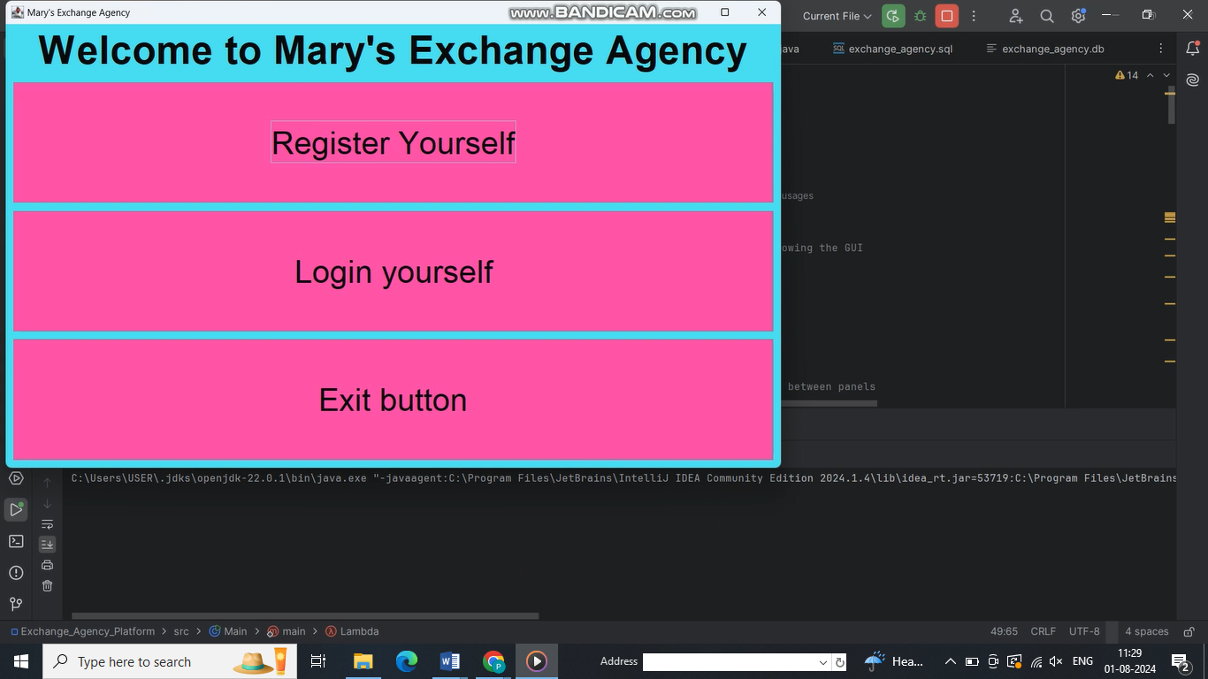

**Figure 1: Home Page**

**Source: (Self-made)**

This picture delineates a pivotal web application interface for "Mary's Exchange Agency". The interface grandstands three fundamental capacities: client choice, login, and an exit choice. The design is simple, utilizing a shining color plot of cyan and pink, which makes the buttons stand out. This sort of application show up conceivably be overhauled with AI in a number of ways:

* **Intelligent client verification:** AI may progress security by recognizing irregular login plans.
* **Personalized user experience:** AI might tailor the interface based on client inclines and behavior.
* **Predictive analytics:** AI may expect client needs and offer essential organizations proactively.
* **Chatbot integration:** An AI-powered chatbot might give diminutive client back.
* **Fraud detection:** AI calculations show up screen exchanges for suspicious improvement.

These AI progressions show up fundamentally make strides comfort and client encounter in such web applications.

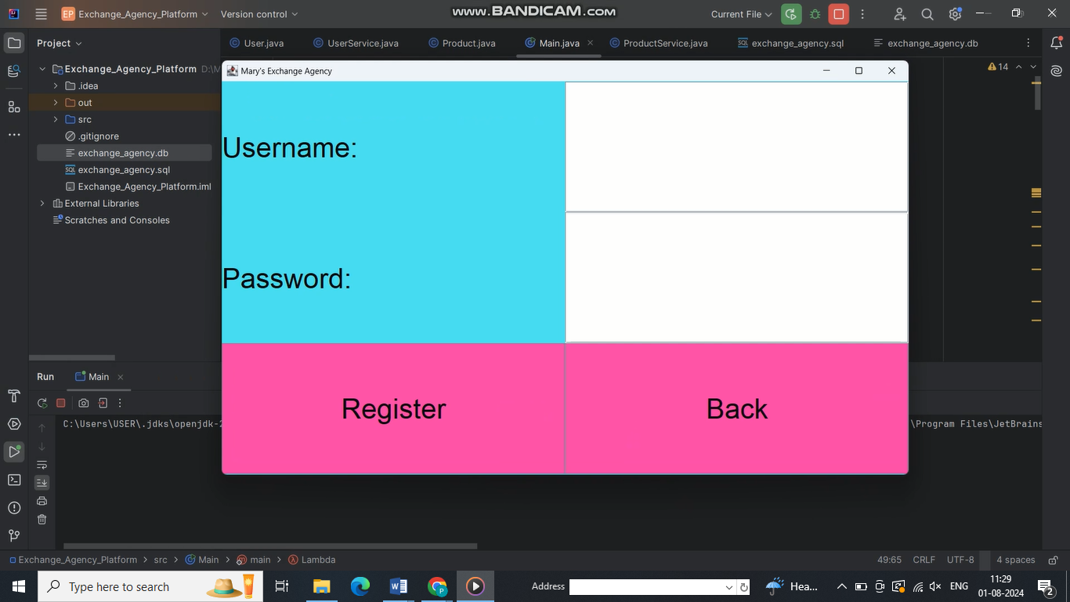

**Figure 2: Register Page**

**Source: (Self-made)**

This picture appears up a clear enrollment interface for Mary's Exchange Agency, a web application. The orchestrate highlights a coordinate organize with input ranges for username and watchword, together with "Register" and "Back" buttons. The color plot businesses isolating cyan and pink, making the interface clearly particular.

From a web application point of see, this talks to a basic client affirmation system. Interior the setting of AI integration, such an interface may be moved forward with cleverly highlights. AI might be utilized to propose solid passwords, recognize potential security dangers, or permit real-time input on password quality. Machine learning algorithms may analyze client behavior plans to recognize suspicious works out within the middle of enrollment. As well, AI-powered chatbots may offer diminutive offer help to clients going up against challenges within the middle of the determination handle, moving forward by and sweeping client involvement and diminishing potential disillusionments.

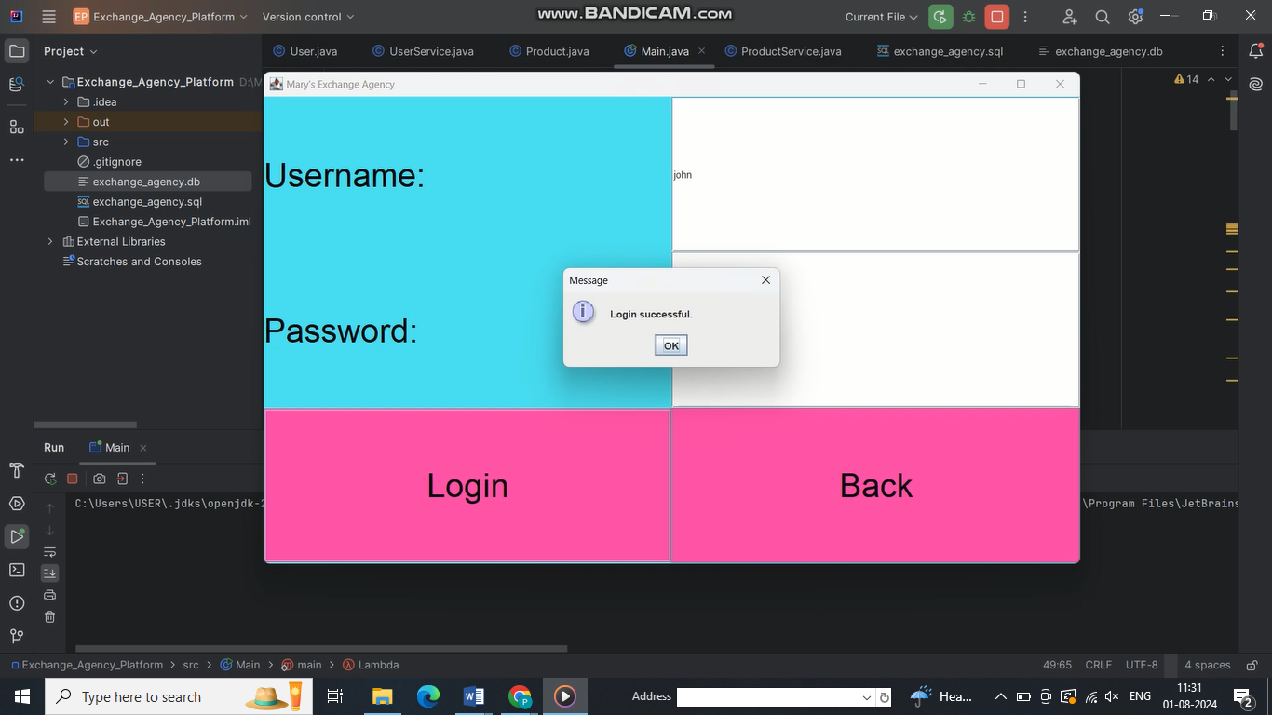

**Figure 3: Login Page**

**Source: (Self-made)**

This picture shows up a login interface for Mary's Exchange Agency, appearing a crucial web application orchestrate. The interface joins districts for username and password, with "Login" and "Back" buttons. A popup message outlines beneficial login, laying out a basic client input instrument. Interior the space of AI-enhanced web applications, this principal interface may be fundamentally updated. AI might give sagaciously confirmation, analyzing composing plans or device fingerprints for extra security. Machine learning algorithms might personalize the client involvement upon login, modifying the interface or substance based on client behavior and inclines. Natural language processing show up empower voice-activated logins or chatbot offer help for login issues. Prescient AI show up expect client needs, pre-loading imperative data or proposing works out based on past normal. These AI integrator would change a fundamental login handle into a smart, adaptable, and user-centric involvement.

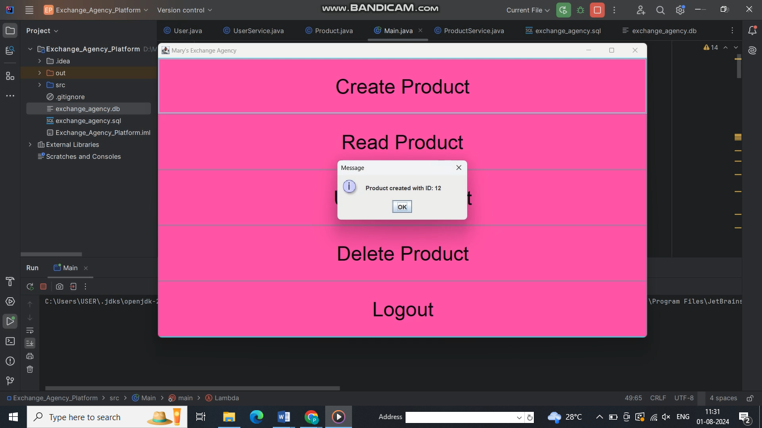

**Figure 4: Create Product**

**Source: (Self-made)**

This picture appears up a thing organization interface for Mary's Exchange Office, including fundamental CRUD (Create, Read, and Delete) operations and a logout elective. The pink foundation with isolating substance makes a basic, user-friendly organize. A popup message affirms fruitful thing creation, laying out principal client criticism.

In an AI-enhanced web application setting, this interface can be essentially redesigned. AI show up mechanize thing categorization, propose idealize assessing based on publicize plans, or expect thing execution. Natural language processing might empower voice commands for thing organization. Machine learning algorithms might analyze client behavior to personalize the interface orchestrate and streamline regularly utilized capacities. AI-powered chatbots show up permit miniature offer help for complex thing organization assignments. Other than, prescient AI might expect client works out, pre-loading pertinent information or proposing taking after steps, in this way advancing effectiveness and client encounter in thing organization workflows.

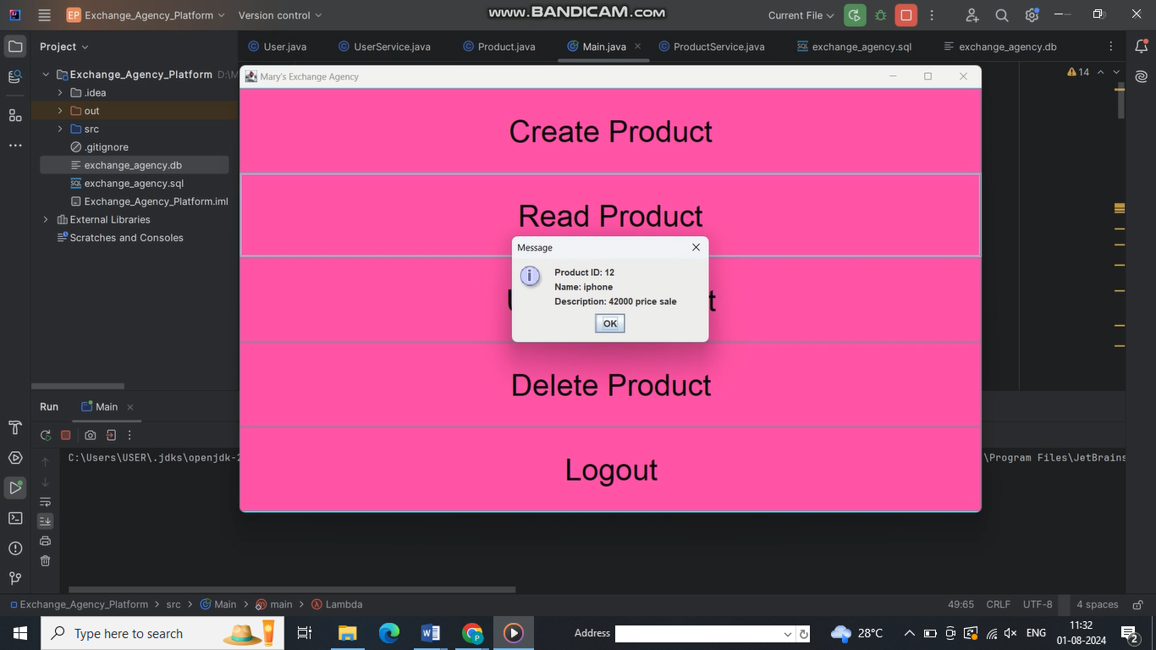

**Figure 5: Read Product**

**Source: (Self-made)**

This picture shows up a thing organization interface for Mary's Exchange Agency, highlighting choices to Form, Examined, and Delete products, alongside a Logout work. The interface businesses a lively pink foundation with clearly characterized parcels. A popup message appears up thing unnoticeable components (ID: 12, Title: iphone, Description: good price sale), laying out basic information recovery esteem.

In an AI-enhanced shape of this web application, common tongue planning might empower more naturally thing delineations and looks. Machine learning calculations show up analyze thing plans, recommending idealize assessing or stock levels. AI show up personalize the client interface based on person utilization plans, prioritizing regularly utilized capacities. Prescient analytics might expect client needs, pre-loading basic thing data. Computer vision AI may offer help in thing picture confirmation and categorization. These AI integrator would modify this principal interface into a smart, adaptable framework that overhauls practicality and client affiliation in thing organization.

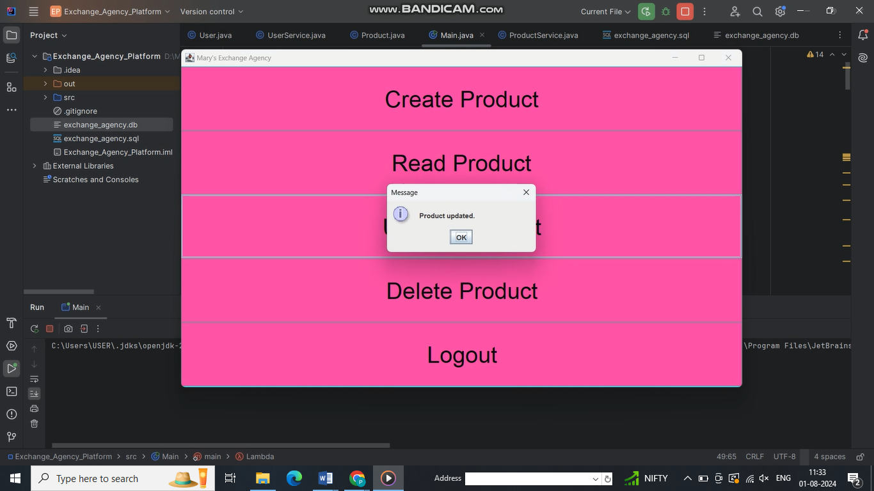

**Figure 6: Update Product**

**Source: (Self-made)**

This picture appears up a thing organization interface for Mary's Exchange Agency, highlighting choices for Create, Read, and Delete operations, as well as a Logout work. The interface businesses a shining pink foundation with clear, isolating substance. A popup message certifies a thing update, sketching out fundamental client input.

In an AI-enhanced web application, this interface can be essentially upgraded. AI might robotize thing updates based on advance plans or stock levels. Machine learning calculations might analyze client behavior to foresee and propose likely works out. Natural language processing might lock in voice-controlled thing organization. AI-driven personalization show up modify the interface orchestrate to person client inclines and penchants. Prescient AI show up expect potential issues in thing organization and offer proactive courses of activity. These AI integrator would modify this clear interface into a smartly, adaptable framework that overhauls effectiveness and client encounter in thing organization tasks.

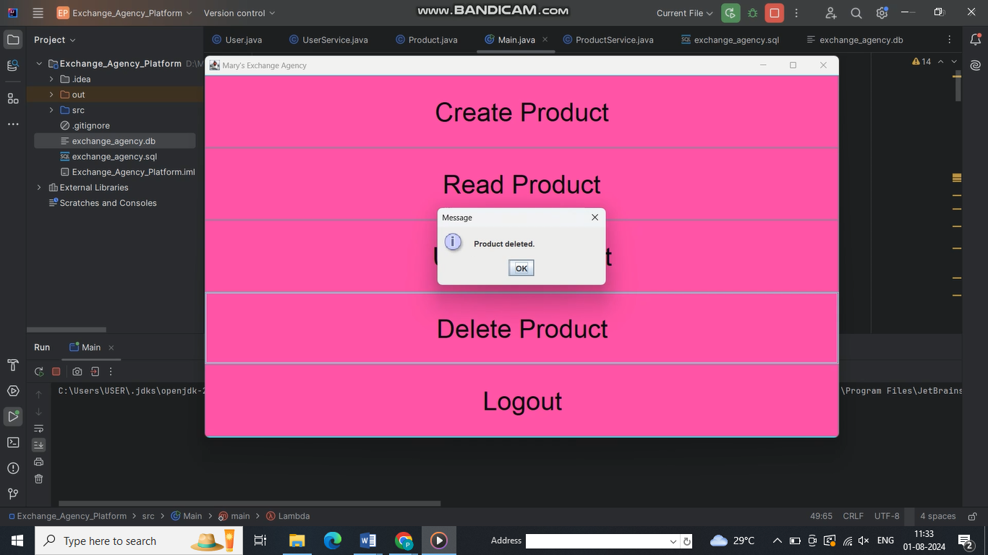

**Figure 7: Delete Product**

**Source: (Self-made)**

This picture shows up a thing organization interface for Mary's Exchange Agency, highlighting choices for Create, Read, and Delete operations, in conjunction with a Logout work. The interface vocations a lively pink foundation with clear substance names. A popup message affirms a thing cancellation, sketching out basic client input value.

In an AI-enhanced web application, this interface can be interior and out progressed. AI may execute smart deletion traditions, analyzing thing affiliations many time as of late discharge. Machine learning may anticipate client excitedly, pre-emptively affirming high-impact erasures. Natural language processing may empower voice-commanded deletions. AI-driven analytics might give bits of data on cancellation plans, proposing stock optimizations. Prescient AI might expect require for thing discharges based on deals plans or typicality. These AI integrator would modify this basic annihilate certification into and cleverly framework that updates decision-making, capability, and information insightfulness in thing organization forms.

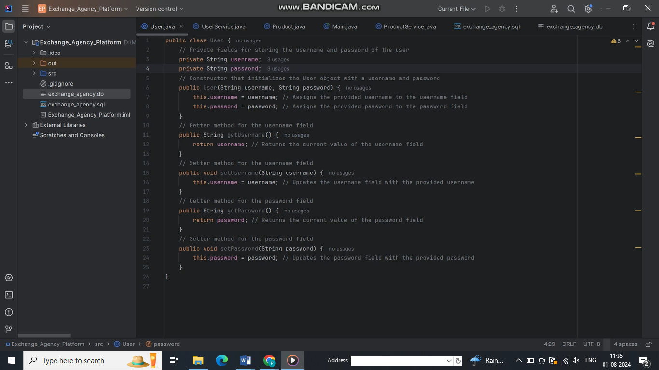

**Figure 8: Java User Class in IDE**

**Source: (Self-made)**

This picture shows up a Java class named "User" in an integrated development environment (IDE), likely for a web application. The lesson speaks to client data with private zones for username and password, connecting to comparing getter and setter techniques. This structure takes after object-oriented programming benchmarks and is common in web applications for client organization. Insides the setting of AI and web applications, such classes routinely serve as data models for client certification systems, conceivably intruded with databases and AI-driven security highlights like abnormality zone or personalized client experiences based on behavior analysis.

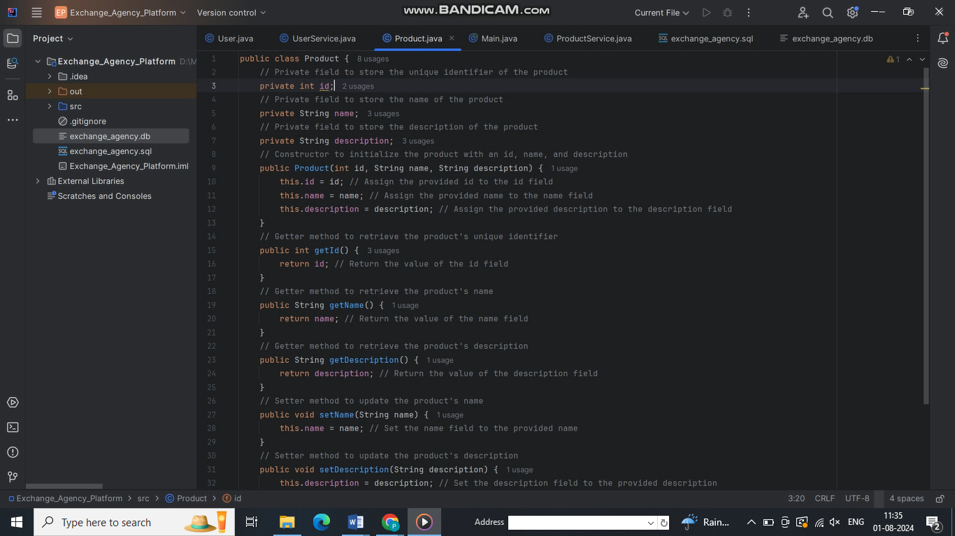

**Figure 9: Java Product Class in IDE**

**Source: (Self-made)**

This picture shows up a Java "Product" class, conventional in web application development. It solidifies zones for id, title, and depiction, with comparing getter and setter procedures. This structure is common in e-commerce or stock organization frameworks. In AI-driven web applications, such classes can be utilized to create thing suggestion frameworks, perform estimation examination on thing portrayals, or actualize exuberant assessing algorithms. The organized information show up licenses for direct integration with machine learning models for errands like thing categorization or inquire assessing, upgrading the application's encounters and client experience.

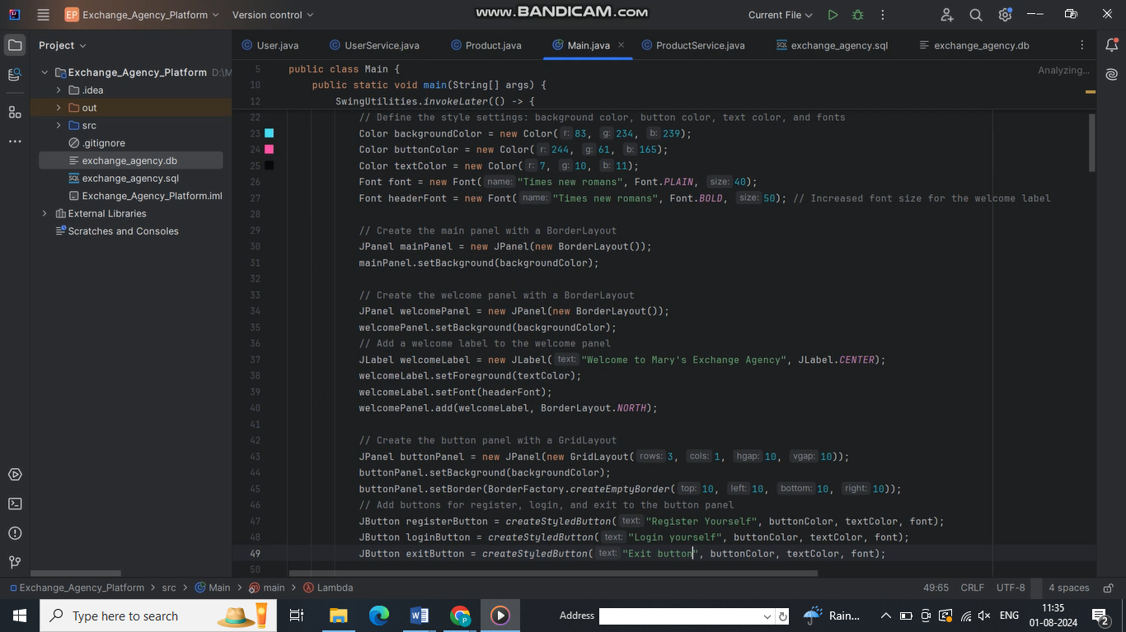

**Figure 10: Java GUI Setup in Main Class**

**Source: (Self-made)**

This picture appears up the most course of a Java application, centering on GUI setup utilizing Swing components. It diagrams the creation of sheets, names, and buttons with custom colors and fonts. This code likely serves as the section point for a web-based or desktop application's client interface. Interior the setting of AI and web applications, such GUI setups can be upgraded with AI-driven highlights like enthusiastic subject adjustments based on client inclines, cleverly layout filling offer help, or real-time language interpretation of UI components. The organized approach to UI creation licenses for clear integration of AI-powered components to move forward client experience and accessibility.

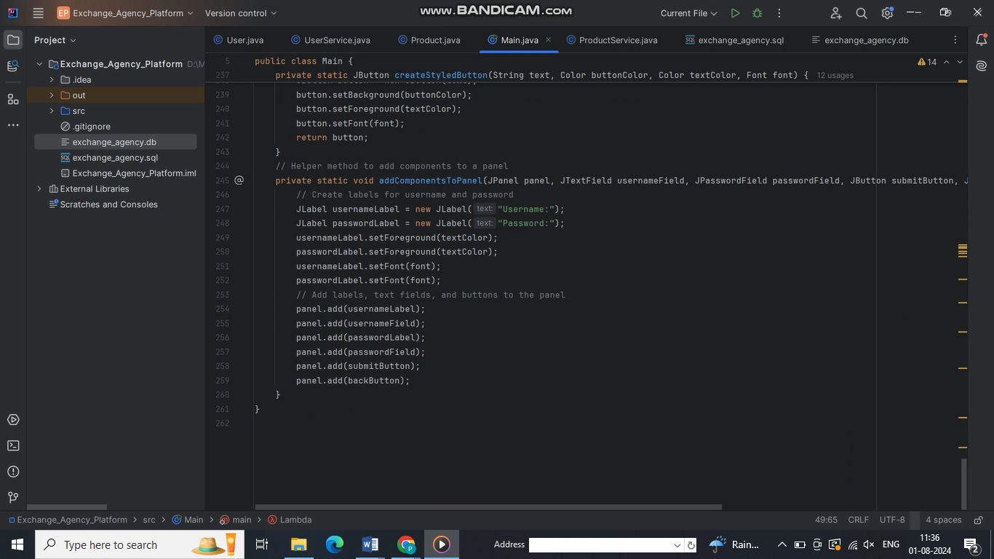

**Figure 11: Java GUI Component Creation and Assembly**

**Source: (Self-made)**

This picture appears up Java code for making and assembling GUI components, particularly for a login interface. It joins strategies for styling buttons and tallying differing components (labels, text fields, and buttons) to a board.

Interior the setting of web applications and AI, such organized UI creation can be expanded with AI-driven highlights. For case, intelligent shape underwriting, real-time password quality examination, or adaptable UI plans based on client behavior plans. The isolated approach to component creation awards for clear integration of AI organizations, such as biometric confirmation or peculiarity disclosure in login endeavors, advancing both client affiliation and security in web applications.

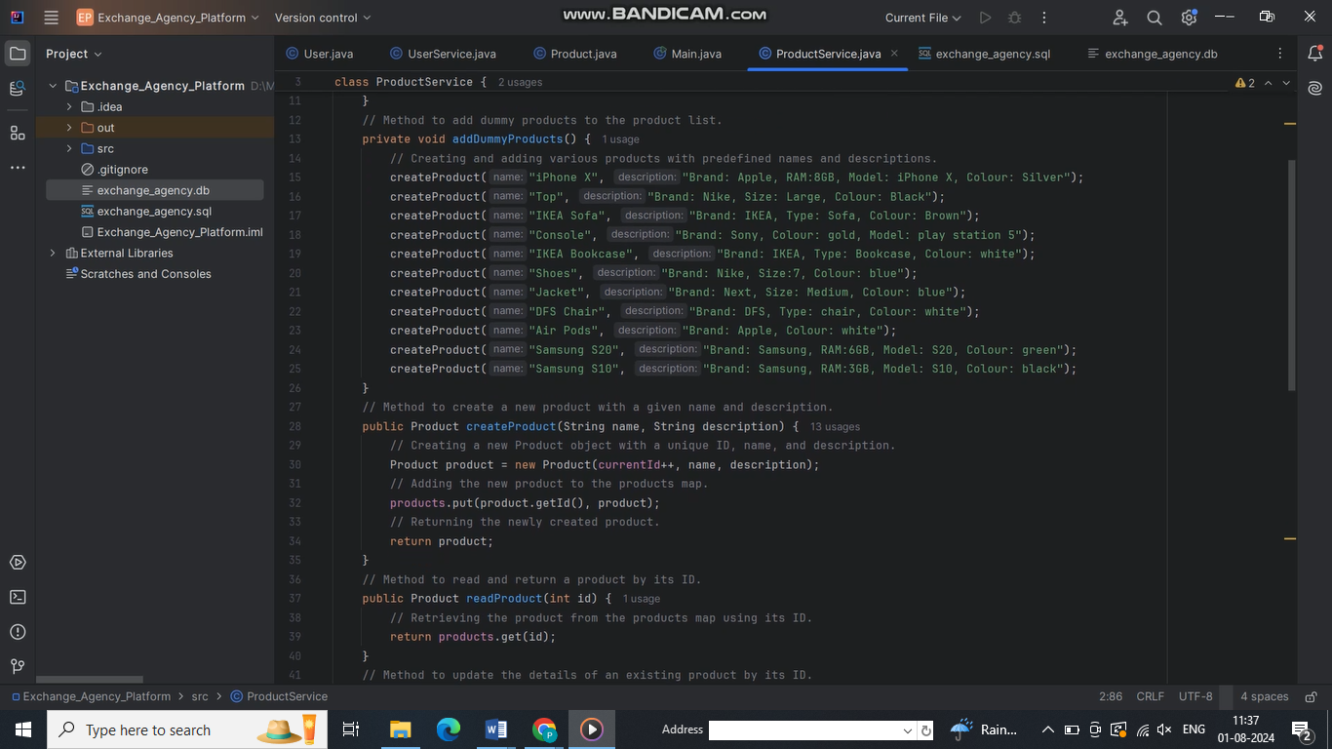

**Figure 12: Product Service Class Implementation**

**Source: (Self-made)**

This picture shows up a Java ProductService class, essential for web application backend introduce. It joins strategies for counting pretense things, making unused things, and recuperating things by ID. In an AI-enhanced web application, this structure may support highlights like computerized thing categorization, enthusiastic surveying, or personalized thing proposals based on client behavior and inclines.

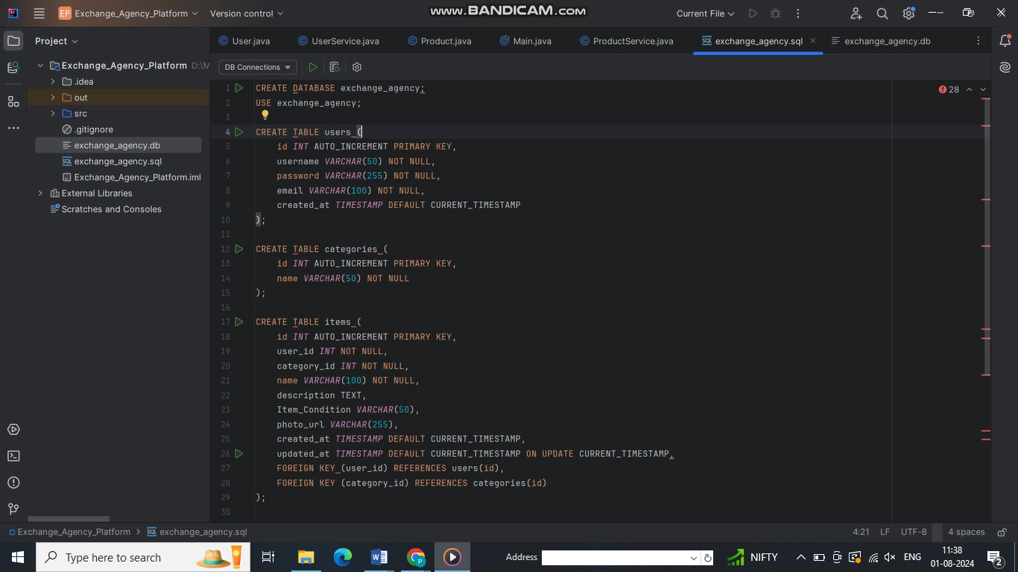

**Figure 13: Database Schema for Exchange Agency Platform**

**Source: (Self-made)**

This picture portrays the SQL script for making the database plan for the Exchange Agency platform. It joins commands for setting up three tables: clients, categories, and things, adjoining to their particular ranges and information sorts. The script builds up fundamental and outside key affiliations to guarantee information cleverness and back the application's functionalities.

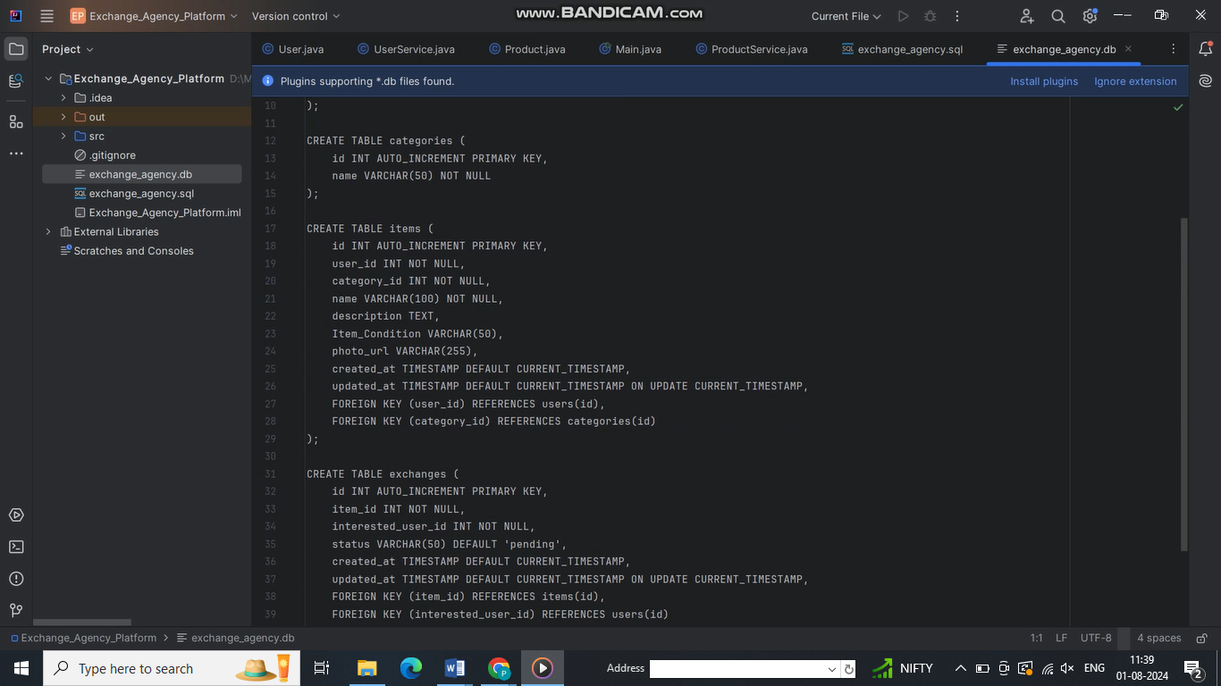

**Figure 14: SQL Schema for Exchange Agency Platform**

**Source: (Self-made)**

The picture takes after the SQL improvement for an Exchange Agency Platform. It highlights the structure of three tables: categories, things, and exchanges, showing up the affiliations among them utilizing blocked off keys. This arrange serves as the spine for the platform's database, ensuring down to earth data organization and recuperation.

# Conclusion

The development of the internet application for Mary's Exchange Agency grandstands the compelling integration of web headways and AI to create an eager and cleverly organize. By taking after best practices in organize plans, database orchestrate, and client involvement, the application offers an overpowering course of activity for enabling online trades. The thought of AI overhauls comfort, giving clients with prescient experiences that streamline the methodology of posting and trading things. The successful utilization of this wander outlines the potential of combining web applications with AI to create imaginative courses of activity that address real-world needs. As headway proceeds to advance, such integrator will gotten to be persistently fundamental in making applications that are not since it were utilitarian but other than cleverly and user-centric.

# Reference

Du‐Harpur, X., Watt, F.M., Luscombe, N.M. and Lynch, M.D., 2020. What is AI? Applications of artificial intelligence to dermatology. *British Journal of Dermatology*, *183*(3), pp.423-430.

Kim, A., Park, M. and Lee, D.H., 2020. AI-IDS: Application of deep learning to real-time Web intrusion detection. *IEEE Access*, *8*, pp.70245-70261.

Haleem, A., Javaid, M., Qadri, M.A., Singh, R.P. and Suman, R., 2022. Artificial intelligence (AI) applications for marketing: A literature-based study. *International Journal of Intelligent Networks*, *3*, pp.119-132.

Parkar, R., Payare, Y., Mithari, K., Nambiar, J. and Gupta, J., 2021, July. AI and web-based interactive college enquiry chatbot. In *2021 13th International Conference on Electronics, Computers and Artificial Intelligence (ECAI)* (pp. 1-5). IEEE.

Gill, S.S., Xu, M., Ottaviani, C., Patros, P., Bahsoon, R., Shaghaghi, A., Golec, M., Stankovski, V., Wu, H., Abraham, A. and Singh, M., 2022. AI for next generation computing: Emerging trends and future directions. *Internet of Things*, *19*, p.100514.

Amershi, S., Weld, D., Vorvoreanu, M., Fourney, A., Nushi, B., Collisson, P., Suh, J., Iqbal, S., Bennett, P.N., Inkpen, K. and Teevan, J., 2019, May. Guidelines for human-AI interaction. In *Proceedings of the 2019 chi conference on human factors in computing systems* (pp. 1-13).

Makkar, A., Ghosh, U. and Sharma, P.K., 2021. Artificial intelligence and edge computing-enabled web spam detection for next generation IoT applications. *IEEE Sensors Journal*, *21*(22), pp.25352-25361.

Martínez-Fernández, S., Bogner, J., Franch, X., Oriol, M., Siebert, J., Trendowicz, A., Vollmer, A.M. and Wagner, S., 2022. Software engineering for AI-based systems: a survey. *ACM Transactions on Software Engineering and Methodology (TOSEM)*, *31*(2), pp.1-59.

Zhang, K. and Aslan, A.B., 2021. AI technologies for education: Recent research & future directions. *Computers and Education: Artificial Intelligence*, *2*, p.100025.

Pokrivcakova, S., 2019. Preparing teachers for the application of AI-powered technologies in foreign language education. *Journal of Language and Cultural Education*, *7*(3), pp.135-153.